# Web Programming 202 – Assignment SPEC

Brian McGowan – S00165159

With the project brief in mind and with an idea from my cousins my idea is for a website that hosts accredited medical services providers who are selling their services. Service providers will be able to register to advertise their services by regions, provide multiple service and across multiple regions.

Intended target audiences for this site would be Medical practitioners on one side, and people looking for medical services of varying types.

Users will be able to search using whatever search term they want, and optionally filter by service type, and potentially by region to return a list of all services available on the website. Clicking on each record will bring you to another page which will provide additional details and functionality for each provider (though this is out of scope for this current assignment)

The design aim of the project is to use semantic ui to style the site or potentially bootstrap. I have a familiarity with bootstrap myself, so if I find too many issues with semantic ui, I may switch to bootstrap out of necessity.

Provided below is a mockup of the search page on the site, detailing the search results and a breakdown of how the page is to be constructed as a process flow. The breakdown is not complete, but some elements are possibly out of scope for this assignment

## Project Breakdown

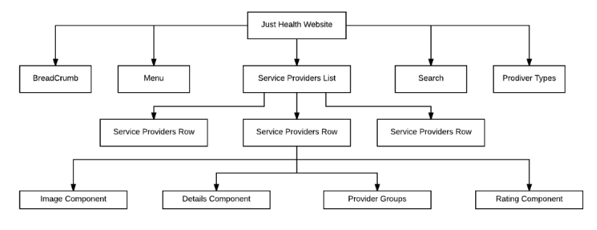

## Wireframe Mockup

